11th Sunday of Pentecost August 9, 2026
Prairieland Parish
As we unite in worship today, we extend a warm welcome to each one present. May we together experience the presence of God
+++++++++++++++++++++++++++++++++++++++++++++++++.
We Gather to Prepare Our Hearts to Meet Our Lord

Prelude
Welcome
Announcements

Today’s passage is about Jesus’ walking on the water. Jesus invites Peter to step out of the boat and come to him. Can we trust in Jesus enough to step out and do the things that we cannot do without trusting Jesus? After taking a few steps on the water, Peter begins to doubt. How far can we go without doubting what Jesus is offering us?

Call to Worship

Heavenly Father, when we hear your invitation to venture out of our comfort zone

Strengthen our trust in you to continue onward without wondering if we do take more steps, will we be able to continue. Help us to keep the words of today’s Gospel in our minds, rather than our thoughts of fear that limit or replace our trust in you.

Peter trusted with his first step out of the boat, but quickly lost focus and began to doubt that he could follow the invitation Jesus gave him,

Forgive us when doubt overcomes us, because we do not have the strength to trust that your power is greater than the Earthly limitations our minds concentrate on.

Prayer of Confession

The final words of your Son Jesus, before he ascended into heaven, were “Go and make disciples of all nations.” Yet we hold back from even sharing the good news, because of our fear that we cannot possibly be able to take the necessary steps. Fear of what may happen should the next step lead us to that sinking feeling of not being able to continue on. Help us to remember Jesus held out his hand to prevent Peter from sinking. Amen

Assurance of God’s care for us

The gift of the Holy Spirit is not a gift you give only to take that gift back and leave us. Strengthen our trust in you to know what gifts you have given us, are ours to keep. All we have to do is be willing to share those gifts with others. Help us to overcome our fear that your words may not be received as we would like them to be. The rich man that walked away sad did not place doubt in Jesus’ mind, even though he did receive the words and immediately welcome them. Just as a planted seed takes time to sprout, give us the courage to continue planting seeds in others about your wondrous ways.

Praise Hymn UMH #117 O God, Our Help in Ages Past

The Word of God

Gospel Lesson………………………………………..Matthew 14: 22 – 33

The Word of God for the People of God! THANKS BE TO GOD

Children’s Time

Faith Hymn UMH #374 Standing on the Promises

Message

Prayers for the People —The Lord’s Prayer

Offering/Doxology/Prayer

Departing Hymn #349 Turn Your Eyes Upon Jesus

Departing Words

As you depart today, go boldly knowing God is front of you to guide you, behind you to protect you, above you to watch over you, beneath you to support you, alongside of you to lean on should the journey become weary. But most of all, God is within you. Boldly go out into the mission field that is beyond the walls of this church building and let the world see and know that God lives in you. Amen.

Postlude (you are welcome to remain to listen to the postlude)

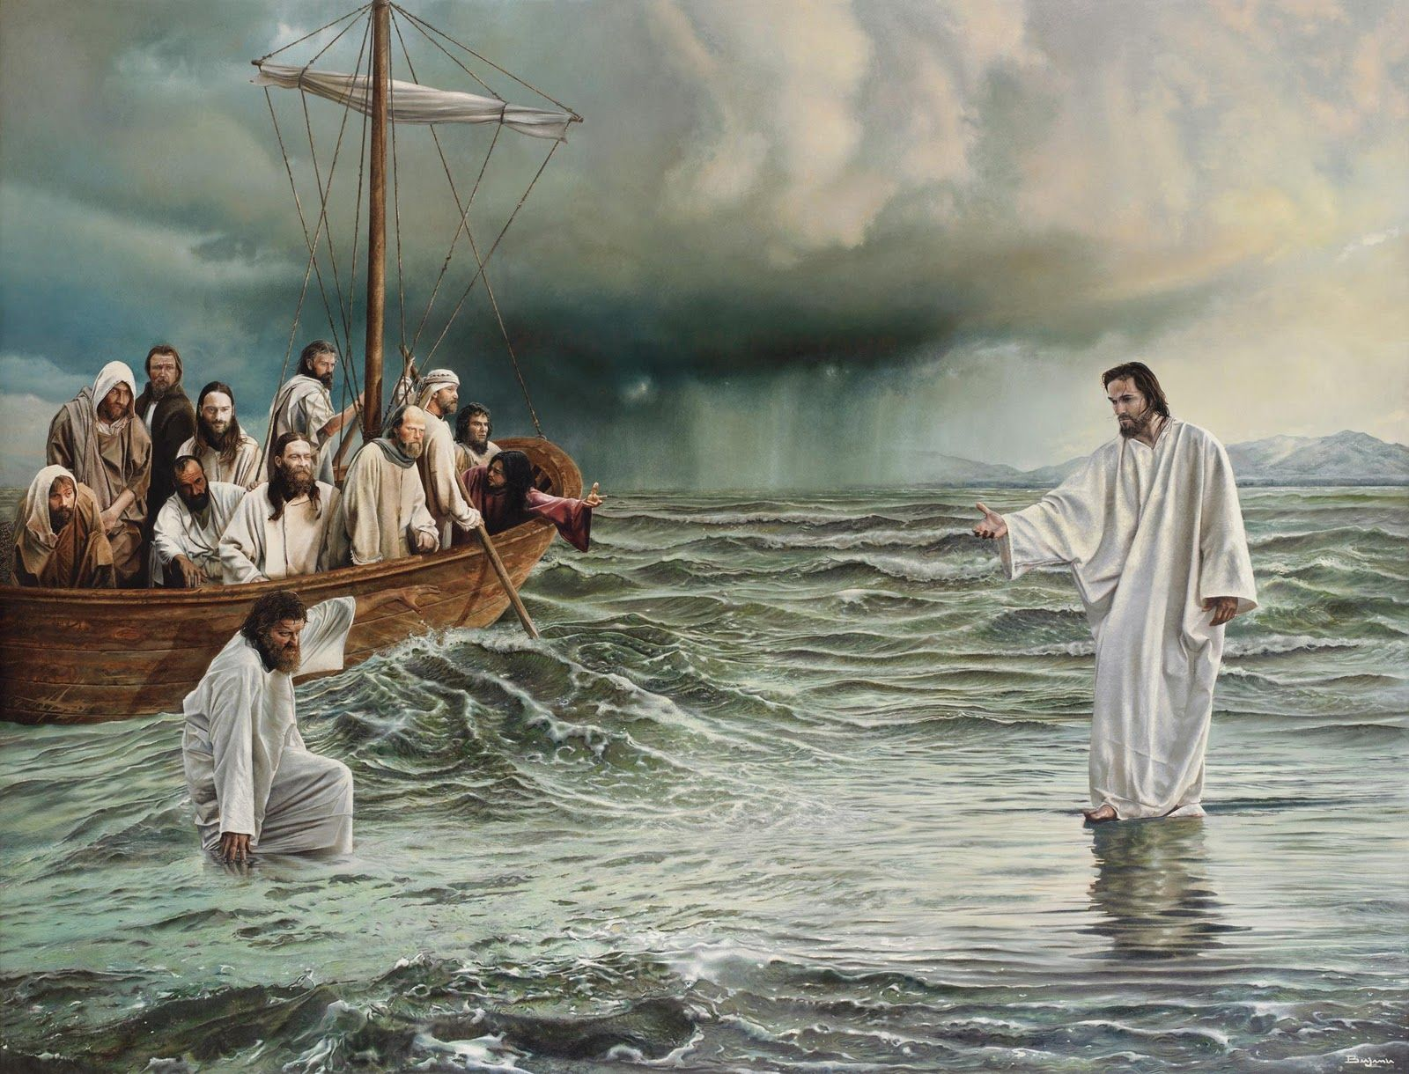

Jesus walks on the water

Matthew 14: 22 – 33

August 9, 2026

